CS 255 System Design Document Template

UML Diagrams

UML Use Case Diagram
The use case diagram highlights the key groups that interact with DriverPass and the core services it offers. Customers enjoy managing their accounts, choosing packages, scheduling lessons, engaging in online learning, and tracking their progress. Staff members play a vital role in supporting scheduling, taking notes, generating reports, managing users, and overseeing packages. Meanwhile, the DMV System ensures that training content stays up to date with regular updates.
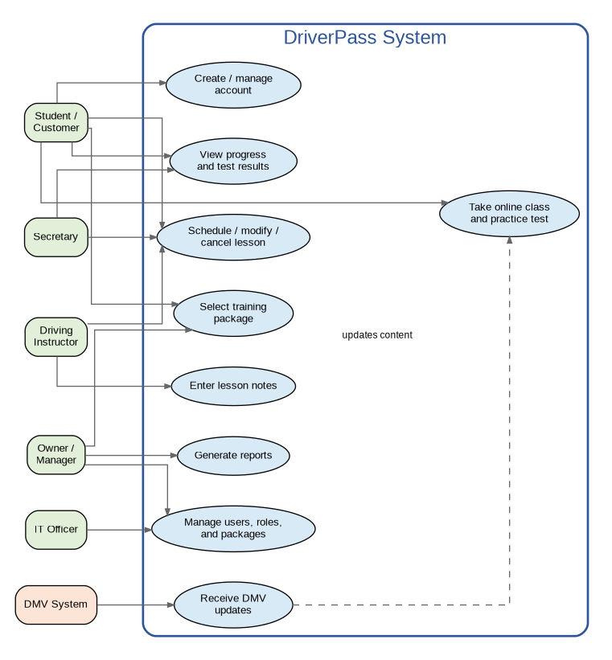

UML Activity Diagrams

Activity Diagram 1: Schedule a Driving Lesson

This activity diagram illustrates how the appointment scheduling process works. It helps DriverPass by ensuring students can easily book lessons only when an instructor and package are available, and by providing the secretary with a way to help when a suitable time isn't available. It’s designed to make the whole experience smoother and more welcoming for everyone involved.
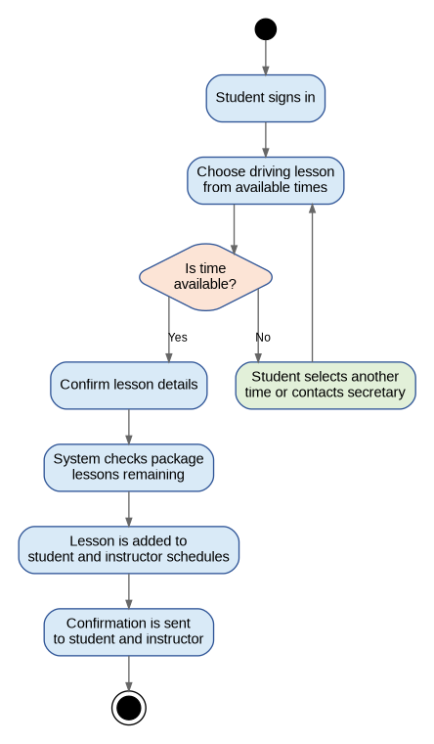

Activity Diagram 2: Complete Online Class and Practice Test

This activity diagram illustrates how students can effortlessly complete their online preparation. It nicely supports DriverPass by tracking test completions, saving scores, and gently guiding students to review materials if they don't pass. These features make the learning process more supportive and encouraging.
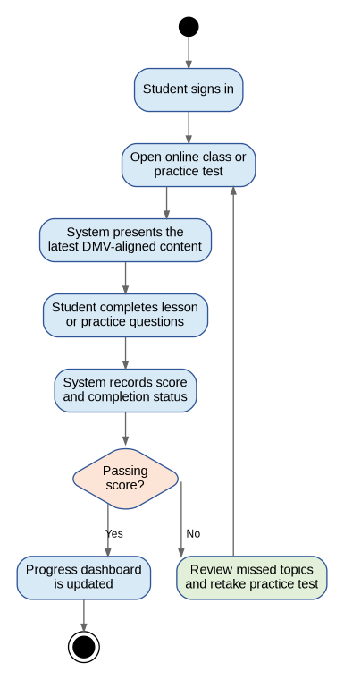

UML Sequence Diagram

The sequence diagram highlights the process of scheduling a driving lesson. It illustrates how the student, DriverPass website, scheduling service, instructor calendar, database, and notification service work together smoothly and in a coordinated way.
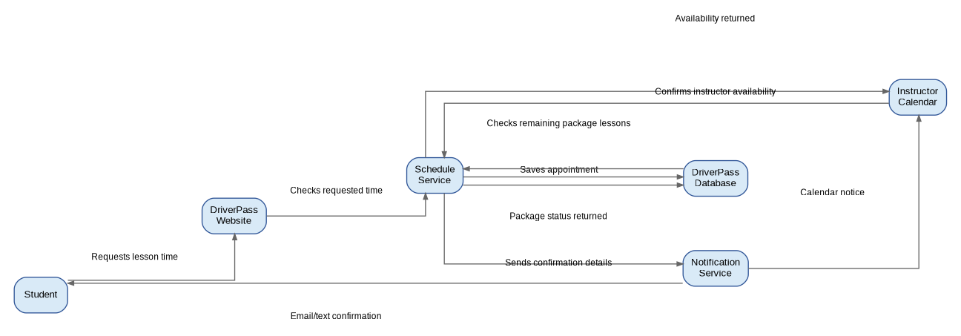

UML Class Diagram

The class diagram outlines the key information groups the system needs to store and supports features such as account security, scheduling, online learning, progress tracking, reporting, and DMV updates. This clear organization ensures everything runs smoothly and efficiently.
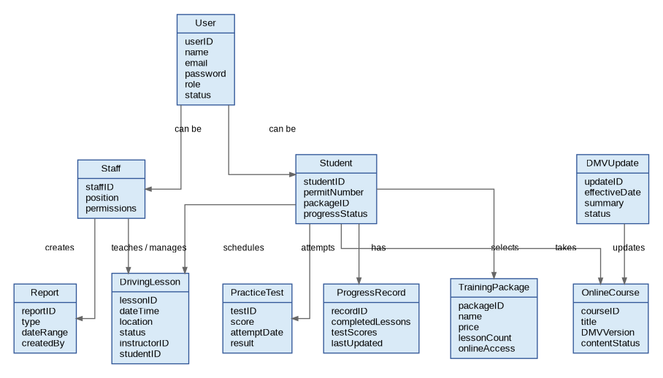

Technical Requirements

The proposed DriverPass system is a secure, easy-to-use, cloud-based web application that you can access effortlessly from your desktop, tablet, or mobile device. It’s carefully crafted to accommodate everyone, whether you're a customer, instructor, secretary, manager, or IT staff, and it helps keep your personal information safe while ensuring your schedules and training records are always accurate and current.

Requirement Area | Technical Requirement
Hardware | Users simply need internet-connected computers, tablets, or smartphones to get started. For the DriverPass office team, having dependable workstations, up-to-date browsers, and networked printers can really make their day easier, especially when printing reports or paper records. Plus, with cloud hosting, DriverPass can avoid the burden of maintaining large on-site servers, making everything smoother and more efficient.
Software | The system should feature a user-friendly web portal with secure login options, convenient scheduling tools, engaging online training modules, practice tests for preparation, insightful reporting dashboards, and intuitive administrative screens for managing packages and users. It’s important that the application works smoothly across popular browsers like Chrome, Edge, Safari, and Firefox, ensuring a seamless experience for everyone.
Infrastructure | A cloud-based application server and database are designed to store accounts, schedules, course progress, test scores, packages, and reports, making everything easily accessible and organized. To ensure smooth operation, features such as automated backups, uptime monitoring, and disaster recovery are included, so DriverPass can continue running seamlessly even if technical issues arise.
Security | The system must employ encrypted connections, role-based access control, strong password policies, secure password reset procedures, session timeouts, audit logs, and regular security updates. Access to sensitive customer and staff data should be restricted to individuals who need it for their responsibilities.
Integrations | The system should support DMV content updates, ensuring that online classes and practice tests stay current with the latest rules. Email or text notifications can be used to send appointment confirmations, schedule changes, reset password messages, and other important reminders, helping users stay informed and connected.
Performance and Availability | The system should load promptly during regular business hours, allowing multiple users to access it simultaneously. It's also important that it stays accessible outside of office hours, so customers can study or schedule lessons comfortably from home.
Data and Reporting | The database needs to keep a friendly record of lesson history, instructor availability, training packages, progress, practice test scores, and user activity. Managers will find it helpful to generate reports that give them a clear view of sales, appointments, and student progress, making it easier to stay organized and supportive.
Maintenance | IT staff should have the necessary tools to easily update users, change roles, disable packages, review activity logs, and apply system updates smoothly, all while ensuring DriverPass continues to run seamlessly. This way, they can maintain security and efficiency without any interruptions.

Functional Requirements Addressed

- Customers can easily create and manage their accounts, choose training packages that suit their needs, schedule or change driving lessons at their convenience, complete online classes comfortably, take practice tests to prepare, and view their progress to stay motivated.
- Secretaries are happy to assist customers with managing their schedules and checking on their progress whenever they need support.
- Driving instructors can easily check their upcoming lessons and jot down notes once a lesson is finished, making everything more organized and straightforward.
- Managers can create reports and oversee package offerings.
- IT staff can handle user accounts, roles, and system access with ease, ensuring everything runs smoothly and securely.

Nonfunctional Requirements Addressed

- The system is thoughtfully built to ensure your access is secure, always available when you need it, and that your customer data is stored accurately and safely.
- The system allows students to access it easily from both mobile devices and desktop computers, so they can use the service conveniently from home or at DriverPass.
- The system can be easily kept up to date as DMV guidance evolves, ensuring it remains current and reliable.
- The system thoughtfully uses backups and monitoring to help reduce downtime and prevent data loss, ensuring your experience remains smooth and secure.

